
CLIENT EDUCATION HANDOUT

Customer Name, Street Address, City, State, Zip code
Phone number, Alt. phone number, Fax number, e-mail address, web site

Anorexia and Decreased Food Intake
Basics
Overview
- Anorexia (decreased or absent food intake) in a nonspecific sign of disease
- It is a common sign of systemic disease
- When associated with gastrointestinal disease it can be caused by any condition that affects prehension, chewing, or swallowing

Signalment
- Any breed, age, or sex can be affected

Signs
- Decreased food intake or complete loss of interest in food
- Certain food types are not consumed

Causes
- Systemic disease
- Diseases of the mouth, lips, tongue, facial muscles, temporomandibular joint, pharynx
- Dental disease
- Neurologic diseases resulting in inability to chew or swallow (e.g. tetanus, equine protozoal myeloencephalopathy, guttural pouch mycosis, botulism, rabies, equine herpesvirus infection)
- Diseases affecting the chewing muscles (masseter muscles)
- Inability to reach food (e.g. painful neck when fed from the ground)
- Anxiety (e.g. herd rank)
- Unpalatable or spoiled food

Risk Factors
- Dependent on the underlying disease

Treatment
- Dependent on the underlying disease

Appropriate Health Care
- Rule out systemic disease
- Rule out diseases as described above
- Appetite-stimulating medications are not usually given to horses; once the underlying cause is determined and resolved horses will resume eating
- Force feeding is difficult in horses and can only be attempted short term; it has to be performed by a veterinarian

Activity
- Dependent on the underlying disease

Diet
- Offer palatable food
- Offer different kinds of food
- Ensure access to water at all times
- Oral electrolyte solutions can be offered during periods of low food intake
- High-energy complete feed should be offered if horses are only able to prehend small amounts of feed

Surgical Considerations
- Dependent on the underlying disease

Medications
- Dependent on the underlying disease

Follow-Up
- Dependent on the underlying disease

Patient Monitoring
- Daily monitoring of water intake
- If anorexia is prolonged (more than 3 days) daily assessment of electrolyte, acid–base, and hydration status is required

Possible Complications
- Aspiration pneumonia, particularly if swallowing is affected, as food is able to enter the trachea instead of the esophagus
- Dependent on the underlying disease

Expected Course and Prognosis
- Dependent on the underlying disease

Key Points
- Anorexia can be an absolute lack of food intake or partial, just affecting certain types of food or just resulting in decreased food intake
- Anorexia can be a sign of systemic disease, or it can be caused by diseases affecting the ability of prehension, chewing, or swallowing of food
- Feed should be inspected for the correct type of feed, signs of spoilage, or reasons that might make it unpalatable
- The ability of the horse to reach food should be evaluated—consider social factors such as aggressive herd mates, stress, and other management factors as well as medical conditions that might make it difficult for the horse to reach the food
- Dental disease is a common cause for anorexia and teeth should be regularly (once a year) evaluated by a veterinarian
- If other signs of disease are present anorexia is likely to be due to the primary disease and will resolve when the primary disease is resolved
- Forced feeding is often impractical and, if performed with an improper technique, can lead to severe complications such as aspiration pneumonia—it should therefore not be attempted by owners
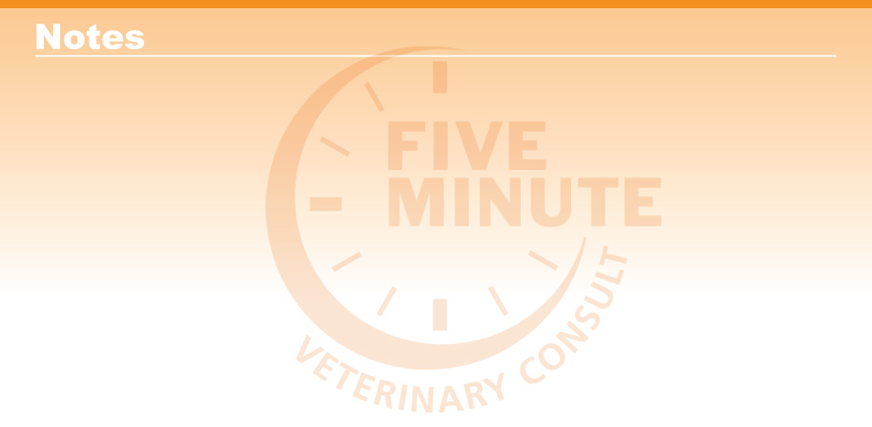

Blackwell's Five-Minute Veterinary Consult: Equine, Third Edition, Jean-Pierre Lavoie © 2020 John Wiley & Sons, Inc.

