**CLIENT EDUCATION HANDOUT**

**Customer Name, Street Address, City, State, Zip code**

**Phone number, Alt. phone number, Fax number, e-mail address, web site**

**Large Colon Torsion**

**Basics**

**Overview**

* Volvulus (twist) of the large colon of varying degrees (90–360°)
* May or may not obstruct the blood supply (strangulating or nonstrangulating) to the colon
* The large colon may be nonviable as a result, leading to death

**Signalment**

* Can affect horses of all ages, breeds, and sex, but broodmares appear predisposed to this condition

**Signs**

* Severe colic pain
* May have distended abdomen

**Causes**

* Exact cause unknown
* Likely to be from a reduction in movement of the colon and gas accumulation

**Risk Factors**

* Change in feeding regimen
* Recent increase in stall rest
* Recent foaling
* Quidding

**Treatment**

* Abdominal surgery

**Appropriate Health Care**

* Surgery is necessary if strangulating volvulus
* Early surgical intervention is very important for survival. An improved outcome is seen in horses with a colic duration of less than 2 hours before surgical intervention
* Medical management may be attempted in horses with a nonstrangulating volvulus but surgery will be necessary for survival in horses with continuing pain and worsening abdominal distention

**Activity**

* Typically, following surgery, horses will be on a period of stall rest (4 weeks) and then small paddock turnout (4 weeks) before normal exercise can be reintroduced

**Diet**

* No feed should be given when the horse is colicky and prior to surgery
* Feed can be reintroduced gradually in the postoperative period

**Surgical Considerations**

* Surgery is indicated for correction of the volvulus

**Medications**

* Analgesia/anti-inflammatory medication such as flunixin meglumine will be given pre- and postoperatively
* Sedative drugs may be given during the colic episode
* Antimicrobials will be administered pre- and postoperatively to try and prevent infection in the abdomen and incision

**Follow-Up**

**Patient Monitoring**

* Horses are usually hospitalized for up to 1–2 weeks following surgery
* Once at home, routine daily monitoring includes assessment of attitude, appetite, and manure production, inspection of incision, and rectal temperature

**Possible Complications**

* Rupture of the large colon before or during surgery
* Nonviable large colon
* Anesthetic-related death
* Abdominal or incisional infection, recurring colic, diarrhea
* Abortion of fetus if a mare is pregnant

**Expected Course and Prognosis**

* If a strangulating volvulus, the horse will die in a matter of hours
* If a nonstrangulating volvulus, the disease will either resolve with medical management or progress to a strangulating volvulus
* Survival is dependent on the length of time the large colon was twisted for and the health of the large colon during surgery. The colon may be resected in some circumstances
* Prognosis for survival can range from 30% to 80% and is dependent on intraoperative findings and postoperative complications
* Horses that make a full recovery can be expected to return to their previous level of function

**Key Points**

* A large colon volvulus is a twist of the gut that may stop the blood supply and lead to a nonviable gut
* Death will ensue if not treated surgically
* Broodmares appear to be at greater risk
* Complications can occur during or after surgery
* Prognosis is dependent on the health of the large colon at surgery and whether or not complications develop

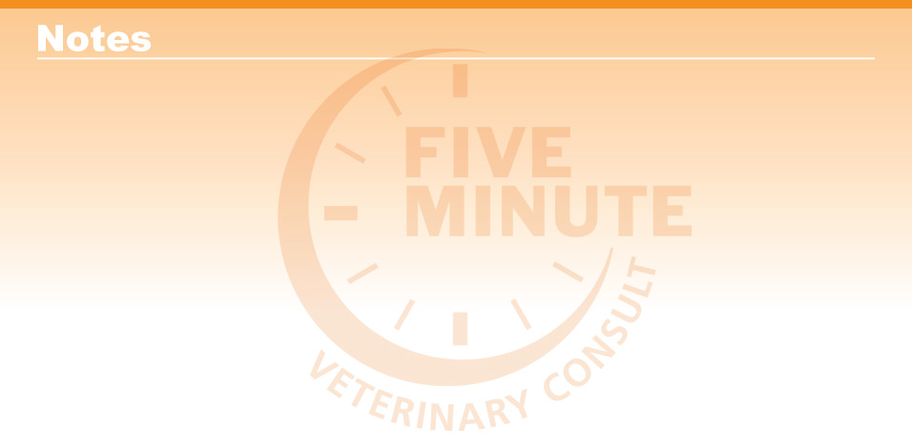

|  |  |
| --- | --- |
| Enter notes here |  |

*Blackwell's Five-Minute Veterinary Consult: Equine, Third Edition,* Jean-Pierre Lavoie © 2020 John Wiley & Sons, Inc.