
CLIENT EDUCATION HANDOUT TEMPLATE

Customer Name, Street Address, City, State, Zip code
Phone number, Alt. phone number, Fax number, e-mail address, web site

Sinusitis (Paranasal)

Basics
Overview
- Paranasal sinusitis is inflammation of the paranasal sinuses, usually caused by a primary or secondary bacterial infection. A less common cause of sinusitis is fungal infection

Signalment
- Affects horses of all ages, breeds, and sex
- Primary sinusitis affects horses usually less than 5 years old

Signs
- The most common clinical sign, regardless of the cause, is purulent nasal discharge from the affected side; fungal infection frequently results in a bloody nasal discharge
- Other signs include tearing and conjunctivitis on the affected side
- Horses may uncommonly be affected bilaterally
- Flow of exudate from the nose may increase when the head is lowered
- Malodorous nasal exudate is characteristically associated with sinusitis caused by dental disease or an expanding mass within the sinuses, whereas odorless exudate is more characteristic of primary bacterial sinusitis
- Facial distortion and obstructed airflow are features of horses with an expanding mass within the sinuses
- Oral examination may reveal evidence of disease of an upper molar or a space between the upper molars

Causes
- A common complication of strangles or may accompany dental disease

Risk Factors
- Horses 1–5 years old are most susceptible to Streptococcus equi infection (strangles) and, therefore, are most susceptible to primary bacterial sinusitis
- The incidence of dental caries and periodontal disease, both of which are causes of dental infection, increases with age, as does the incidence of neoplasia
- Horses that are confined to a stable or have recently undergone surgery of the sinuses are at most risk of developing a fungal infection of the sinuses

Treatment

Appropriate Health Care
- The aim of treatment for primary sinusitis is to resolve infection by administering appropriate antibiotic therapy and by evacuating the exudate. The aim of treatment for secondary sinusitis is to resolve the primary cause of secondary infection
- Solid exudate within the sinuses should be suspected when primary bacterial sinusitis fails to resolve with lavage and antibiotic therapy; solid exudate must be removed
- Fungal sinusitis can usually be resolved by lavaging the affected sinuses with an antifungal agent for 1–2 weeks
- To resolve sinusitis secondary to another disease (e.g. dental disease or a mass within the sinuses), the cause of the sinusitis must be resolved, usually by surgical intervention. Resolution of sinusitis secondary to dental infection usually necessitates removing the infected tooth

Activity
- Exercise should be restricted for at least several weeks after clinical signs of sinusitis have resolved

Diet
- The horse may require fewer calories if confined

Surgical Considerations
- Solid exudate is most easily removed through a large, 3-sided flap created on the forehead. The flap is composed of bone, subcutaneous tissue, and skin
- An infected molar can be extracted, or it can be repelled through a trephine hole or 3-sided flap created the below the eye
- Extracting an infected tooth is usually accompanied by few complications and can be accomplished with the horse standing, whereas repelling a tooth through a trephine hole or a flap can be accompanied by serious complications and is most commonly accomplished with the horse anesthetized

Medications
- Primary bacterial sinusitis—administration of an antibiotic to which streptococci are susceptible (e.g. penicillin), in conjunction with lavage of the sinuses
- Sinusitis secondary to other disease—antibiotic drug(s), either broad spectrum or based on the results of sensitivity testing of cultured bacteria
- Fungal sinusitis—lavage of the affected sinuses with an antifungal agent
- Ancillary treatment for mycotic infection can include systemic administration of sodium iodide and organic iodide until clinical signs have resolved

Follow-Up
- Resolution of abnormal nasal discharge after antibiotic therapy has been discontinued indicates infection has resolved
- Distortion of the nasal cavity caused by an expanding mass resolves within several weeks after the mass has been removed

Possible Complications
- Unsuccessful treatment for primary sinusitis can usually be attributed to retention of solid exudate within the sinuses
- Unsuccessful treatment for sinusitis caused by dental disease can usually be attributed to persistent tooth infection or, less commonly, to the presence of solid exudate within the sinuses

Expected Course and Prognosis
- The long-term prognosis for horses affected by primary or dental sinusitis is good, provided that the horse receives proper treatment

Key Points
- The most common sign of bacterial paranasal sinusitis is purulent nasal discharge from the affected side
- Sinusitis can be primary (i.e. the result of a systemic bacterial infection). Primary bacterial sinusitis is sometimes a sequela to strangles, a type of streptococcal infection
- Secondary sinusitis is usually associated with an infection of an upper molar but can be associated with the presence of a mass within the sinuses
- The aim of treatment for primary sinusitis is to resolve infection by administering appropriate antibiotic therapy and by evacuating exudate. The aim of treatment for secondary sinusitis is to resolve the primary cause of secondary infection, which often entails removing an infected tooth

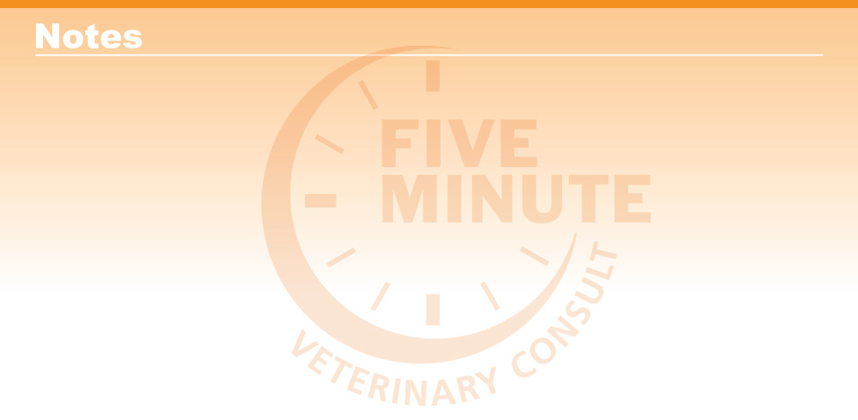
Enter notes here

Blackwell's Five-Minute Veterinary Consult: Equine, Third Edition, Jean-Pierre Lavoie © 2020 John Wiley & Sons, Inc.

